**\*\*\*Due Date: Week 13 – 11 April 2019 (Thursday) by 5.00pm\*\*\***

UECS1144 Object-Oriented Application Development

Group Assignment



|  |  |  |  |
| --- | --- | --- | --- |
| Name | I.D. No | Course | Practical Group |
| Tan Ying Yao | 1703648 | SE | P3 |
| Teh Liang Wei | 1703486 | SE | P1 |
| Lim Zi Yin | 1706602 | SE | P3 |
| Alex Kok Zhen Xian | 1502934 | SE | P3 |
|  |  |  | /Marks |

**Assessment Part I (55%):**

|  |  |  |  |  |  |  |  |  |  |  |  |  |  |  |  |  |  |  |
| --- | --- | --- | --- | --- | --- | --- | --- | --- | --- | --- | --- | --- | --- | --- | --- | --- | --- | --- |
|  |  |  |  | **Missing** | | **Major** | | **Minor** | | **Not** | | **No Issue/** | | **Max** | | | **Marks** |  |
|  |  |  |  | **/ Does** | | **Excellent** | |  |
|  |  |  | **errors** | | **errors** | | **Robust** | | **marks** | | | **Obtained** |  |
|  |  |  |  | **not work** | | **Design** | |  |
|  |  |  |  |  | |  | |  | |  | |  |  |  |
|  |  | 1. **Functionalities** |  |  | | | | | | | | | | | | | |  |
|  |  |  |  |  |
|  |  | Make reservation / booking |  |  |  |  | |  | |  | |  | | **10** | |  |  |  |
|  |  |  |  |  |  |  | |  | |  | |  | |  | |  |  |  |
|  |  | view the bookings status of individual or all venues |  |  |  |  | |  | |  | |  | | **10** | |  |  |  |
|  |  |  |  |  |  |  | |  | |  | |  | |  | |  |  |  |
|  |  | Cancel Reservation |  |  |  |  | |  | |  | |  | | **10** | |  |  |  |
|  |  |  |  |  |  |  | |  | |  | |  | |  | |  |  |  |
|  |  | 1. **Array and Array List** |  |  |  |  | |  | |  | |  | | **10** | |  |  |  |
|  |  |  | |  |  |  | |  | |  | |  | |  | |  |  |  |
|  |  | 1. **Class Diagram** | |  |  |  | |  | |  | |  | | **10** | |  |  |  |
|  |  |  |  |  |  |  | |  | |  | |  | |  | |  |  |  |
|  |  | 1. **General Efforts** |  |  |  |  | |  | |  | |  | | **5** | |  |  |  |
|  |  |  |  |  |  |  | |  | |  | |  | |  | |  |  |  |
|  |  |  |  |  |  |  | |  | |  | |  | |  | |  |  |  |
|  |  |  |  |  |  |  | |  | |  | |  | |  | |  |  |  |
|  |  |  |  |  |  |  | |  | |  | |  | | **Total** | |  |  |  |
|  |  |  |  |  |  |  | |  | |  | |  | |  | |  |  |  |
|  | | | | | | |  | |  | |  | |  | |  |  |  |  |

**Assessment Part II (45%):**

|  |  |  |  |  |  |  |  |
| --- | --- | --- | --- | --- | --- | --- | --- |
| **Components** | **Missing/**  **Does not Work** | **Poor** | **Average** | **Good** | **Excellent** | **Max Marks** | **Marks Obtained** |
| 1. **Window Forms and UI Design** |  |  |  |  |  | **15** |  |
| 1. **File Handling** |  |  |  |  |  | **10** |  |
| 1. **Exception Handling *(try catch block)*** |  |  |  |  |  | **10** |  |
| 1. **Inheritance *(Shown in class diagram)*** |  |  |  |  |  | **5** |  |
| 1. **General: Effort, etc.** |  |  |  |  |  | **5** |  |
|  |  |  |  |  |  | **Total** |  |

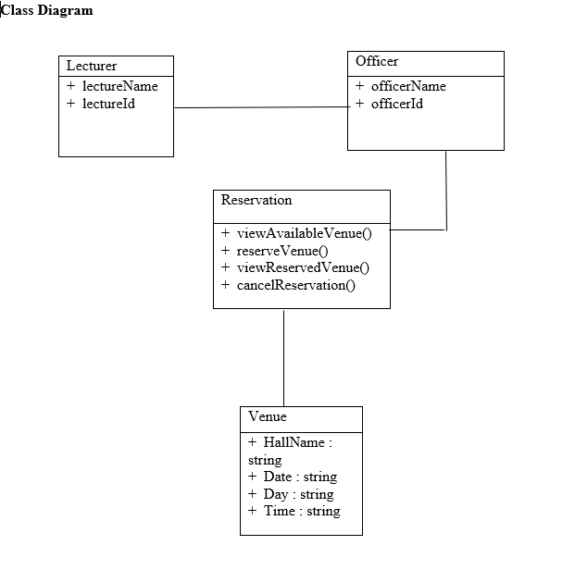

**PART A:**

**Menu of the program**

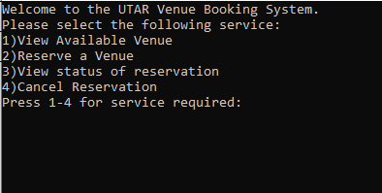

**List available venue from venue.txt**

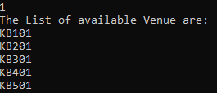

**Each action prompts a confirmation button**



**Booking of venue:**

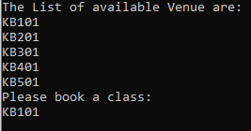

**Choosing Date and Day:**

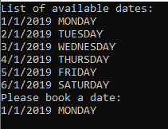

**Choose Starting time & Ending Time**

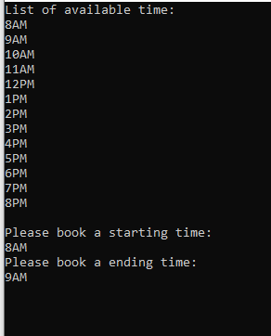

**Status of Reservation read from reservation.txt:**

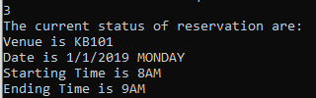

**Cancelling all Reservation:**

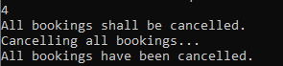

**Reservation has been cancelled:**

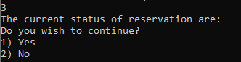

**PART B:**

**Graphical User Interface of the program:**

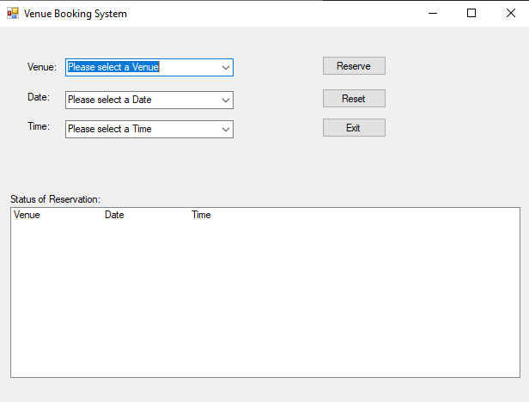

**Select the venue, date and time desired:**

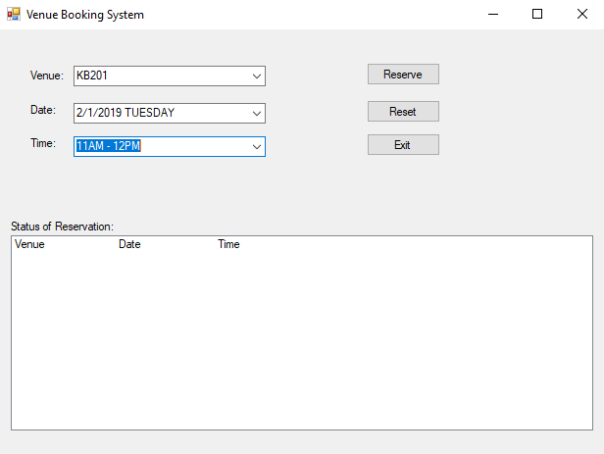

**Selected venue is saved to a text file and shown in the status**

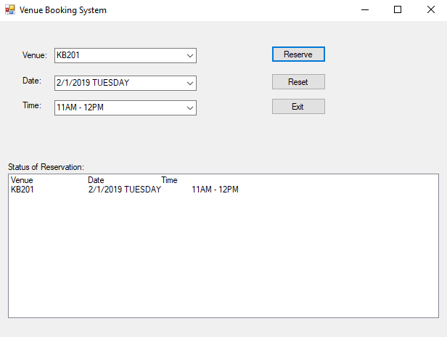

**Press reset to clear fields and a confirmation box will popup**

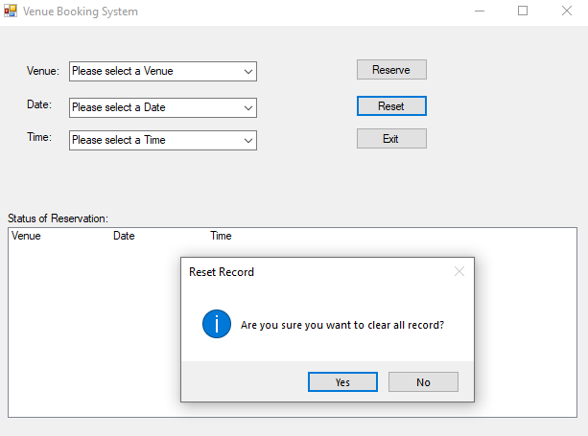

**All field are cleared to default**

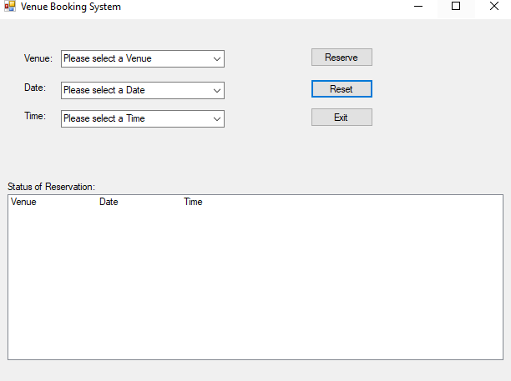

**The details of the venue are saved to the reservation.txt located in the debug folder of the program:**

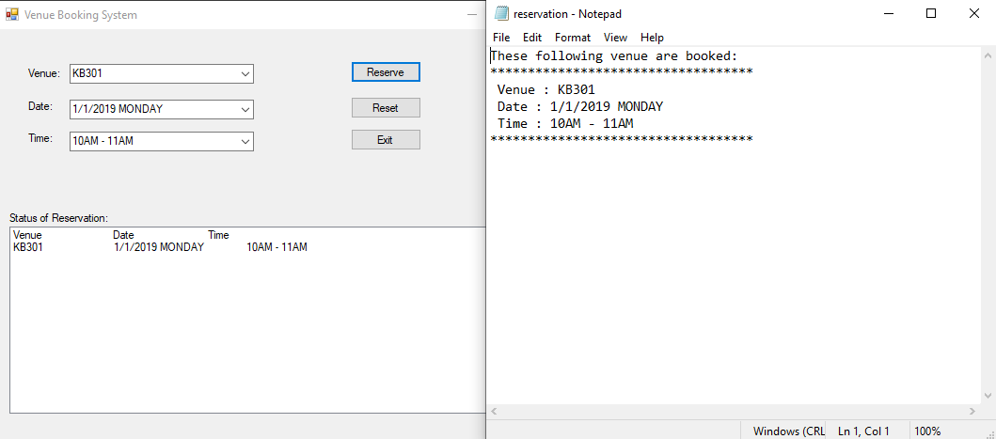

**Program can be exited and a confirmation prompt will appear to confirm intention:**

